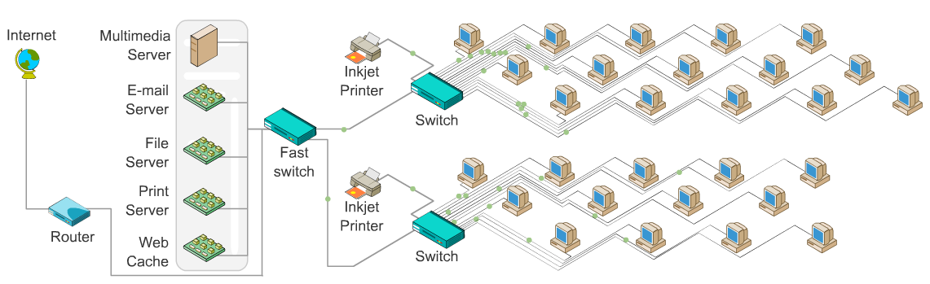
Bibliography
Hardware:
Computers:
Web Developers: http://www.dell.com/ie/p/xps-8700/pd?oc=cdx8716&model_id=xps-8700
Reasons for use:
- 4th Generation Intel Core i7-4790 with 1TB of hard drive
- Initially comes with 12GB RAM
- Optional Dell 22 Monitor | S2240L - 54.5cm(21.5") Black UK (adds €195.57)
- Comes with a 12 month subscription for McAfee Live Safe XPS
- NVIDIA GeForce GTX 745 4GB DDR3 Video Card
- Integrated sound card
- Dell KB213 USB Multimedia Keyboard and Dell Laser Mouse
- 1 year Collect & Return Hardware Support included
- Priced at a total of €1,064.57 (including optional monitor)

Office Users: http://www.dell.com/ie/p/inspiron-3646-small-desktop/pd?oc=cd64611&model_id=inspiron-3646-small-desktop
Reasons for use:
- Intel Celeron Dual Core J1800 Processor with 500GB Hard Drive
- Initially comes with 4GB RAM
- Dell E-series E2014H 49.4cm (19.5”) LED monitor VGA,DVI-D (1600x900)
- 12 month subscription for McAfee Live Safe
- Intel HD Graphics Video Card
- Dell KB 133 USB Entry Keyboard and Dell Optical (Not Wireless), Scroll USB Mouse
- 1 year Collect & Return Hardware Support included
- Priced at a total of €349

Printer: http://www8.hp.com/ie/en/products/printers/product-detail.html?oid=6771948
Reasons for use:
- Print, copy, scan, fax, web, photo
- Multitasking supported
- Costs €160

Software:
Text Editors:
Microsoft Office - http://www.microsoftstore.com/store/mseea/en_IE/pdp/productID.289161200
Reasons for use:
- Comes with Word, Excel, Power Point, One Note, Outlook, Access and Publisher
- Can be used on five PC’s at a time, with a one year subscription at €99.00
- 1TB OneDrive Storage per user

Libra Office - http://www.libreoffice.org/
Reasons for use:
- Free alternative to Microsoft Office

Open Office - https://www.openoffice.org/
Reasons for use:
- Another free alternative to Microsoft Office

Operating System: Both PC’s come with Windows 8.1
Web Developers: http://www.dell.com/ie/p/xps-8700/pd?oc=cdx8716&model_id=xps-8700
Office Users: http://www.dell.com/ie/p/inspiron-3646-small-desktop/pd?oc=cd64611&model_id=inspiron-3646-small-desktop

Internet Browsers:
Google Chrome - http://www.google.com/chrome/
Reasons for use:
- Allows users to access One Drive to share documents
Internet Explorer - http://windows.microsoft.com/en-us/internet-explorer/download-ie
Reasons for use:
- Mainly used for Web Developers to test websites
Mozilla Firefox - https://www.mozilla.org/en-US/firefox/new/
Reasons for use:
- Has increased security

Antivirus:
McAfee - http://www.mcafee.com/us/downloads/downloads.aspx
Reasons for use:
- Malicious URL Blocking
- Reliable
- Multi User option

Norton Internet Security - http://ie.norton.com/norton-security-antivirus
Reasons for use:
- Cost effective
- Reliable
- Multi-user option
- Protects all devices
- Specialised security for each device

Bullguard - http://www.bullguard.com/products/bullguard-antivirus.aspx
Reasons for use:
- Effective at detecting and removing malware
- Cost effective

PDF Reader:
Adobe Reader XI - http://www.adobe.com/ie/products/reader.html
Reasons for use:
- Most complete PDF solution available
- Never a compatibility problem with PDFs
- Create documents that can be electronically signed

Networking:
Servers:
PowerEdge T320 Tower Server - http://www.dell.com/ie/business/p/poweredge-t320/pd
Reasons for use:
- 192GB Memory (6 DIMM slots)
- 32TB Internal Storage
- Intel C602 Chipset

Switches:
Dell Networking Z-Series Core and Aggregation Switches - http://www.dell.com/ie/business/p/force10-z-series/pd
Reasons for use:
- 132 ports
- Low latency
- Four times higher throughput (10 Tbs)

HP 1920 Switch Series - http://www8.hp.com/ie/en/products/networking-switches/product-detail.html?oid=7399514
Reasons for use:
- 48 10/100/1000 ports, maximum, and 4 SFP 1000 Mbps ports
- Throughput - 77.4 Mpps
- Routing/switching capacity - 104 Gbps

Server Racks:
Wall Mount Server Rack - http://www.dabs.ie/products/startech-com-6u-22--wall-mount-server-rack-8G5J.html?src=3
12U Wall Mount Server Rack - http://www.dabs.ie/products/startech-com-wall-mount-server-rack-cabinet-7B7C.html?src=3
12u CCS Server Cabinet - http://www.cablemonkey.ie/600mm-x-1000mm-ccs-server-cabinets-racks/175-12u-600mmw-x-1000mmd-ccs-server-cabinet.html

Routers:
Cisco ASR 1013 Router - http://www.cisco.com/c/en/us/products/routers/asr-1013-router/index.html

Cisco 4000 Series Integrated Services Routers -
http://www.cisco.com/c/en/us/products/routers/4000-series-integrated-services-routers-isr/index.html

Cables:
Solid CAT 7 S/FTP Network cable - http://www.cables.ie/cables/network-cables/solid-cat-cables/solid-cat-7-s-ftp-network-cable.html

CAT 7 Network cable S/FTP - http://www.cables.ie/cables/network-cables/patch-cables/cat-7-network-cable-s-ftp.html

Technical Support:
Dell: http://www.dell.com/support/contents/ie/en/iedhs1/category/Contact-Information/Technical-Support
HP: http://www8.hp.com/ie/en/software-solutions/customer-technical-support-services/

Review Sites:
http://uk.pcmag.com/article/review/
http://computers.toptenreviews.com/multimedia/dell/dell-xps-8700-review.html
http://anti-virus-software-review.toptenreviews.com/
http://www.toptenreviews.com/
http://www.pcmag.com/article2/0,2817,2342445,00.asp
http://uk.pcmag.com/smc-ez-switch-101001000-smcgs8p-smart/23573/review/smc-ez-switch-101001000-smcgs8p-smart
http://uk.pcmag.com/ruckus-zonedirector-1000-and-ruckus-zoneflex-7942/2877/review/ruckus-zonedirector-1000-and-ruckus-zoneflex-7942
http://www.notebookreview.com/softwarereview/adobe-acrobat-review-worth-the-money/

Support Sites:
Dell: http://www.dell.com/support/home/ie/en/iedhs1/Products/
HP: http://www8.hp.com/ie/en/contact-hp/contact.html
Cisco: http://www.cisco.com/cisco/web/support/index.html
Microsoft: http://www.microsoft.com/ireland/about/contact.html
Adobe: http://www.adobe.com/ie/company/contact.html
Network Support: http://www.wrendata.com/content/network-support-services-maintenance

Floor Plan:

